学 院：南京大学软件学院

团 队：第5组

成 员：陈书玉 陈俐俐 程芸菲 陈悦

完成日期：2016/12/11

酒店预定系统

代码度量数据文档

一、更新历史 4

二、metrics截图 4

1. Client 4

2. Server 5

3. Common 5

三、耦合的度量 5

3.1Userbl模块 5

3.1.1Userbl模块内类的CBO和DAC 5

3.1.2Userbl模块内类的NOC和DIT 6

3.2 WebStrategybl模块 6

3.2.1WebStrategybl模块内类的CBO和DAC 6

3.2.2WebStrategybl模块内类的NOC和DIT 7

3.3HotelStrategybl模块 7

3.3.1HotelStrategybl模块内类的CBO和DAC 7

3.3.2HotelStrategybl模块内类的NOC和DIT 8

3.4 personnelbl模块 8

3.4.1personnelbl模块内类的CBO和DAC 8

3.4.2personnelbl模块内类的NOC和DIT 9

3.5 searchhotelbl模块 9

3.5.1searchhotelbl模块内类的CBO和DAC 9

3.5.2 SearchHotel模块内类的NOC和DIT 9

3.6 Checkinbl模块 10

3.6.1Checkinbl模块内类的CBO和DAC 10

3.6.2Checkinbl模块内类的NOC和DIT 10

3.7AvailableRoombl模块 10

3.7.1 AvailableRoombl模块内类的CBO和DAC 10

3.7.2 AvailableRoombl模块内类的NOC和DIT 11

3.8Creditbl模块 11

3.8.1Creditbl模块内类的CBO和DAC 11

3.8.2Creditbl模块内类的NOC和DIT 11

3.9 HotelBL模块 12

3.9.1HotelBL模块内类的CBO和DAC 12

3.9.2HotelBL模块内类的NOC和DIT 12

3.10 OrderBL模块 12

3.10.1OrderBL模块内类的CBO和DAC 12

3.10.2OrderBL模块内类的NOC和DIT 13

四、代码度量 13

1. Total lines of code 13

1.Client 13

2.Server 13

3.Common 13

2. Lines of code and comment 13

1. Client 13

2. Server 14

3. Common 14

3.Number of method 14

1. Client 14

2. Server 14

3. Common 14

# 一、更新历史

|  |  |  |  |
| --- | --- | --- | --- |
| **修改人员** | **修改日期** | **修改原因** | **版本号** |
| 程芸菲 | 2016/12/11 | 创建模板 | V0.1 |
| 全体成员 | 2016/12/11 | 完成草稿 | V0.2 |
| 陈书玉 | 2016/12/11 | 整理  统一字体格式  补充目录 | V0.3 |

# 二、metrics截图

## Client

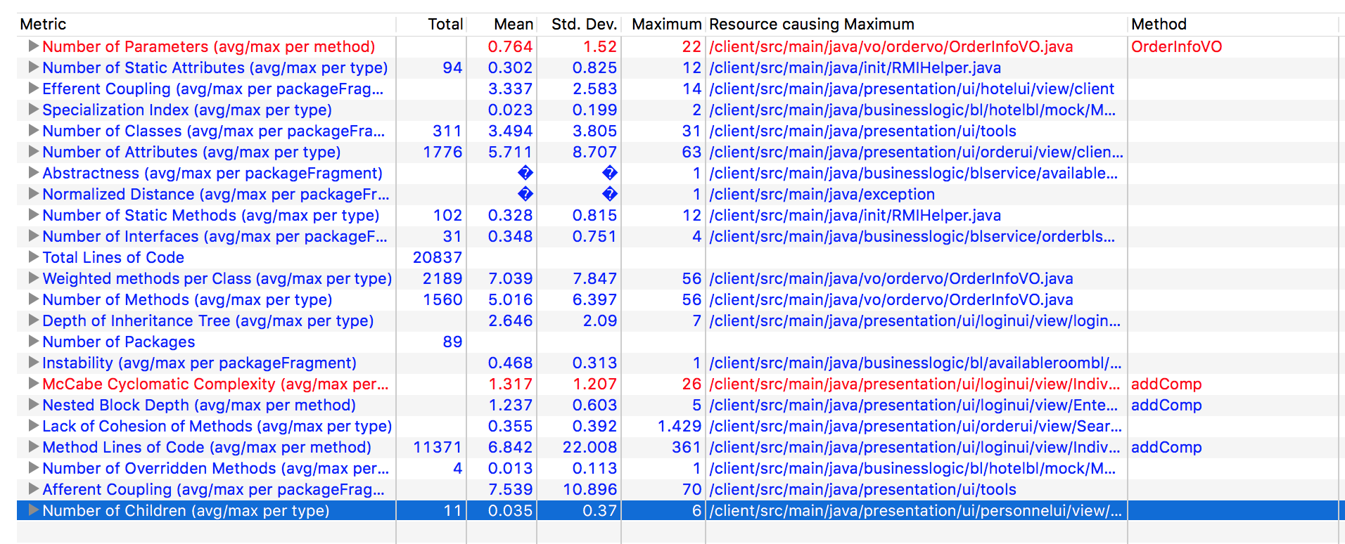

## Server

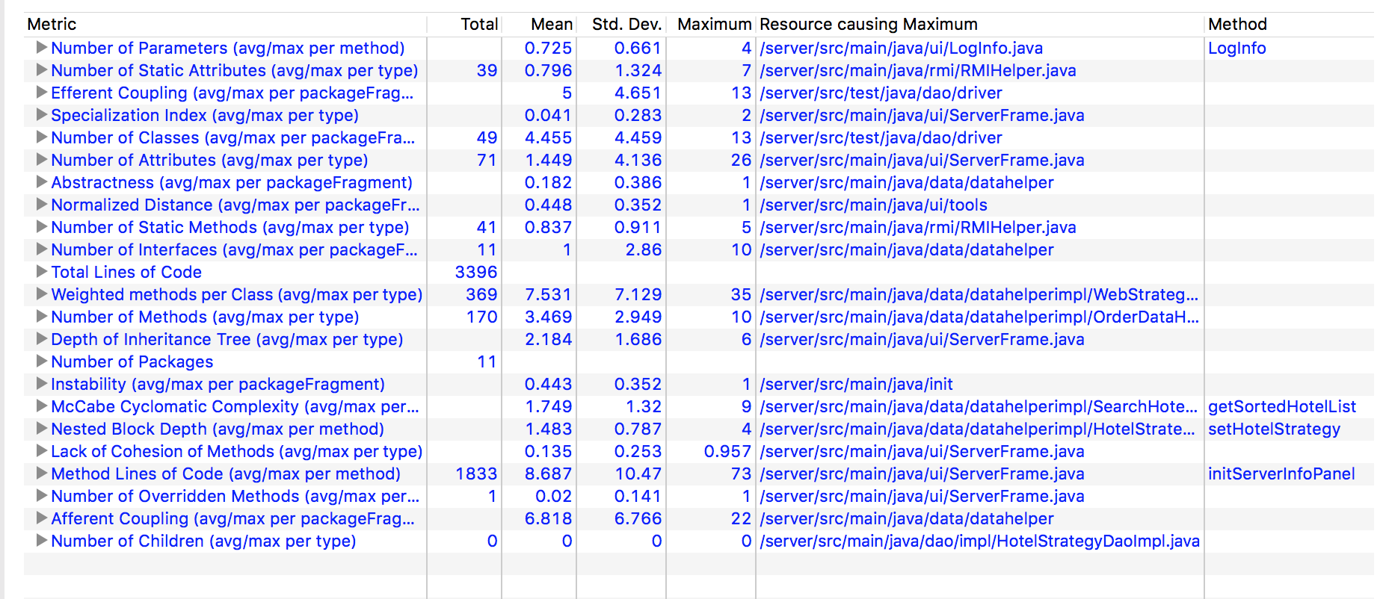

## Common

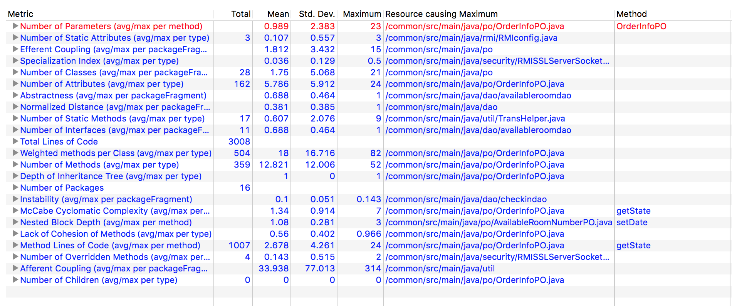

# 三、耦合的度量

## 3.1Userbl模块

### 3.1.1Userbl模块内类的CBO和DAC

|  |  |  |
| --- | --- | --- |
| **类名** | **CBO** | **DAC** |
| User | 4 | 1 |
| 调用其他类4 | UserDao |
| Customer | 2 | 0 |
| 调用其他类  被其他类调用1 |  |

### 3.1.2Userbl模块内类的NOC和DIT

|  |  |  |
| --- | --- | --- |
| **类名** | **NOC** | **DIT** |
| User | 0 | 0 |
| Customer | 0 | 0 |

## 3.2 WebStrategybl模块

### 3.2.1WebStrategybl模块内类的CBO和DAC

|  |  |  |
| --- | --- | --- |
| **类名** | **CBO** | **DAC** |
| webstrategy | 3 | 0 |
| 调用其他类1  被其他类调用2 |  |
| WebGradeRule | 2 | 1 |
| 调用其他类1  被其他类调用1 | webStrategyDao |
| WebSpecialTimeStrategy | 2 | 1 |
| 调用其他类1  被其他类调用1 | webStrategyDao |
| WebVIPStrategy | 2 | 1 |
| 调用其他类1  被其他类调用1 | webStrategyDao |
| WebSpecialAreaStrategy | 2 | 1 |
| 调用其他类1  被其他类调用1 | webStrategyDao |

### 3.2.2WebStrategybl模块内类的NOC和DIT

|  |  |  |
| --- | --- | --- |
| **类名** | **NOC** | **DIT** |
| WebGradeRule | 0 | 0 |
| WebStrategy | 0 | 0 |
| WebSpecialTimeStrategy | 0 | 0 |
| WebVIPStrategy | 0 | 0 |
| WebSpecialAreaStrategy | 0 | 0 |

## 3.3HotelStrategybl模块

### 3.3.1HotelStrategybl模块内类的CBO和DAC

|  |  |  |
| --- | --- | --- |
| **类名** | **CBO** | **DAC** |
| HotelStrategy | 5 | 0 |
| 调用其他类3  被其他类调用2 |  |
| HotelAmountStrategy | 2 | 1 |
| 调用其他类1  被其他类调用1 | webStrategyDao |
| HotelBirthStrategy | 2 | 1 |
| 调用其他类1  被其他类调用1 | webStrategyDao |
| HotelEnterpriseStrategy | 2 | 1 |
| 调用其他类1  被其他类调用1 | webStrategyDao |
| HotelSpecialTimeStrategy | 2 | 1 |
| 调用其他类1  被其他类调用1 | webStrategyDao |

### 3.3.2HotelStrategybl模块内类的NOC和DIT

|  |  |  |
| --- | --- | --- |
| **类名** | **NOC** | **DIT** |
| HotelStrategy | 0 | 0 |
| HotelAmountStrategy | 0 | 0 |
| HotelBirthStrategy | 0 | 0 |
| HotelEnterpriseStrategy | 0 | 0 |
| HotelSpecialTimeStrategy | 0 | 0 |

## 3.4 personnelbl模块

### 3.4.1personnelbl模块内类的CBO和DAC

|  |  |  |
| --- | --- | --- |
| 类名 | CBO | DAC |
| Personnel | 3 | 0 |
| 调用其他类2，被其他类调用1 |  |
| PersonList | 3 | 1 |
| 调用其他类2，被其他类调用1 | ArrayList<PersonListVO> |
| WebMarketMan | 3 | 0 |
| 调用其他类1，被其他类调用2 |  |
| Customer | 3 | 0 |
| 调用其他类1，被其他类调用2 |  |
| HotelWorker | 3 | 0 |
| 调用其他类1，被其他类调用2 |  |

### 3.4.2personnelbl模块内类的NOC和DIT

|  |  |  |
| --- | --- | --- |
| 类名 | NOC | DIT |
| Personnel | 0 | 0 |
| PersonList | 0 | 0 |
| WebMarketMan | 0 | 0 |
| Customer | 0 | 0 |
| HotelWorker | 0 | 0 |

## 3.5 searchhotelbl模块

### 3.5.1searchhotelbl模块内类的CBO和DAC

|  |  |  |
| --- | --- | --- |
| 类名 | CBO | DAC |
| SearchHotel | 4 | 1 |
| 调用其他类3，被其他类调用1 | ArrayList<HotelListVO> |

### 3.5.2 SearchHotel模块内类的NOC和DIT

|  |  |  |
| --- | --- | --- |
| 类名 | NOC | DIT |
| SearchHotel | 0 | 0 |

## 3.6 Checkinbl模块

### 3.6.1Checkinbl模块内类的CBO和DAC

|  |  |  |
| --- | --- | --- |
| **类名** | **CBO** | **DAC** |
| Checkin | 5 | 3 |
| 调用其他类4，  被其他类调用1。 | AvailableRoomDao  AvailableRoom  User |
| CheckinInfo | 2 | 1 |
| 调用其他类1，  被其他类调用1 | BedType |

### 3.6.2Checkinbl模块内类的NOC和DIT

|  |  |  |
| --- | --- | --- |
| **类名** | **NOC** | **DIT** |
| Checkin | 0 | 0 |
| CheckinInfo | 0 | 0 |

## 3.7AvailableRoombl模块

### 3.7.1 AvailableRoombl模块内类的CBO和DAC

|  |  |  |
| --- | --- | --- |
| **类名** | **CBO** | **DAC** |
| AvailableRoom | 4 | 2 |
| 调用其他类2，  被其他类调用2。 | ArrayList<SingleAvailableRoomInfo>  AvailableRoomDao |
| SingleAvailableRoomInfo | 2 | 1 |
| 调用其他类1，  被其他类调用1。 | AvailableRoomDao |

### 3.7.2 AvailableRoombl模块内类的NOC和DIT

|  |  |  |
| --- | --- | --- |
| **类名** | **NOC** | **DIT** |
| AvailableRoom | 0 | 0 |
| SingleAvailableRoomInfo | 0 | 0 |

## 3.8Creditbl模块

### 3.8.1Creditbl模块内类的CBO和DAC

|  |  |  |
| --- | --- | --- |
| **类名** | **CBO** | **DAC** |
| Credit | 3 | 2 |
| 调用其他类2，  被其他类调用1。 | AvailableRoomDao  User |

### 3.8.2Creditbl模块内类的NOC和DIT

|  |  |  |
| --- | --- | --- |
| **类名** | **NOC** | **DIT** |
| Credit | 0 | 0 |

## 3.9 HotelBL模块

### 3.9.1HotelBL模块内类的CBO和DAC

|  |  |  |
| --- | --- | --- |
| **类名** | **CBO** | **DAC** |
| Hotel | 8 | 1 |
| 调用其他类5，  被其他类调用3 | AvailableRoom |

### 3.9.2HotelBL模块内类的NOC和DIT

|  |  |  |
| --- | --- | --- |
| **类名** | **NOC** | **DIT** |
| Hotel | 0 | 0 |

## 3.10 OrderBL模块

### 3.10.1OrderBL模块内类的CBO和DAC

|  |  |  |
| --- | --- | --- |
| **类名** | **CBO** | **DAC** |
| Order | 8 | 2 |
| 调用其他类7，  被其他类调用1 | OrderList  SingleOrder |
| OrderList | 3 | 2 |
| 调用其他类1，  被其他类调用2 | ArrayList<SingleOrder>  OrderDao |
| SingleOrder | 7 | 1 |
| 调用其他类5，  被其他类调用2 | OrderDao |

### 3.10.2OrderBL模块内类的NOC和DIT

|  |  |  |
| --- | --- | --- |
| **类名** | **NOC** | **DIT** |
| Order | 0 | 0 |
| OrderList | 0 | 0 |
| SingleOrder | 0 | 0 |

# 四、代码度量

# Total lines of code

## 1.Client

20837

## 2.Server

3396

## 3.Common

3008

# Lines of code and comment

## Client

20837

## Server

3396

## Common

3308

# 3.Number of method

## Client

1560

## Server

170

## 3.Common

359